Genetic characterization of Istrian goat: key-point for long-term conservation

Ante Ivanković¹, Boro Mioč¹, Gordan Šubara², Peter Dovč³, Ivan Širić¹, Jelena Ramljak^{1*}

¹University of Zagreb Faculty of Agriculture, Svetošimunska cesta 25, 10 000 Zagreb, Croatia
²Agency for Rural Development of Istria, , 52 000 Pazin, Croatia
³Biotechnical Faculty, University of Ljubljana , Grpblje 3, Domžale, Slovenia

Abstract
Istrian goat is an autochthonous Croatian breed which inhabited Istrian peninsula and was important in milk production and human nutrition, especially for poor people. For centuries Istrian goat was a recognizable heraldic symbol of Istria, but in her real form almost disappeared from the breeding area. The revitalization and reaffirmation of Istrian goat began with several dozen remaining breeding animals, after a decade-long breeding ban. Genetic characterization of the Istrian goat population is necessary for providing insight into the state of genetically preserved structure within population as well as positioning Istrian goats within phylogenetically related breeds. Microsatellite and mtDNA analysis of reproductive individuals of Istrian goat and related breeds, Croatian White goat and Saanen goat was carried out. In the population of Istrian goat, higher allelic variability (nA = 9.7; AR = 7.4) were found as well as significant genetic distance (F_{ST} = 0.068 - 0.086) in relation to other two breeds. These results indicate that Istrian goat constitutes a separate genetic identity. The observed ten haplotype sequences of the D-loop mtDNA also confirm the significant genetic richness of the maternal hereditary component. The observed haplotypes in the population of Istrian goat belong to lineage A. A smaller number of haplotypes shows similarity to the group of “white” goats, indicating traces of earlier limited but targeted crossing of Istrian goats. The genetic profile analysis of Istrian goats indicates a high level of genetic variability and provides guidelines for a long-term conservation program. The preserved genetic and promising potential of milk production of Istrian goat makes a significant basis for her economic reaffirmation. Orientation of the breed towards milk production could be an efficient strategy for its effective preservation.

Key words: Istrian goat, genetic diversity, microsatellite, mtDNA, conservation

*Corresponding author: e-mail: jramljak@agr.hr

Introduction
Goats (Capra hircus) were among the first domesticated livestock animals. They have been contributing to the economical, agricultural and social life of the human civilization (Joshi et al., 2004). According to archaeological and genetic evidence, goats were first domesticated from Capra aegagrus in the Fertile Crescent region of the Near East between 10,000 to 12,000 years ago, at the beginning of the Neolithic revolution (Zeder and Hesse, 2000; Zeder et al., 2006; Colli et al., 2015). Actually, the goats are among the “big five” livestock species and total population reached approximately one billion (FAOSTAT, 2015), distributed in 1,233 goats breeds (DAD-IS, 2017). Breeding area of the Europe and the Caucasus have the biggest share of goat breeds (374; 30.2%). According to FAO (2015) only 23.1% goat breeds are not in risk from extinction and for 60.8% breeds risk status is unknown. Local breeds are part of genetic and sociocultural heritage of local community and for this reason it is very important to preserve genetic diversity of the remaining breeds, mostly captured in nonselected autochthonous breeds (Medugorac et al., 2009). Istrian goat is one of the three autochthonous goat breeds, which suffered a severe reduction in population size in the past. Despite her long history, the Istrian goat is officially registered as an autochthonous breed by the Ministry of Agriculture (National Gazette 80/2013). Today's population of Istrian goats is in status of critically endangered breed (CAA, 2016).
Istrian goat and goat husbandry have a long tradition in Istria. In the life of medieval Istria, goat breeding was of crucial importance for daily survival of population. In the situation of possible war and other unfavourable disasters, her modest requirements in terms of food and shelter as well as her high fertility, gave the goat an advantage over other species of domestic animals. Consequently, soon after the end of the crisis, the livestock could quickly revitalise, providing the population with sufficient quantities of milk, meat, chamois leather, wool and manure. During the Austro-Hungarian Empire, the Austrian provincial authorities, trying to protect the forest from excessive browsing, issued a general decree banning the goat keeping in Istria in 1884, as the first measure in resolving the karst issue (Beltram and Klanjšček, 1947). After the fall of the Austro-Hungarian Empire, the ban for breeding of Istrian goats was removed, and 20 years later, about 13.000 goats inhabited Istrian peninsula. After the Second World War goats were still considered as a pest and the main enemy of forests. Final negative impact to goat breeding in Istria happened at former Yugoslavia in 1954 with the introduction of the Law on keeping the goats, which virtually forbid the goat as a domestic animal in Istria. Goat farming over the next half century was rather marginalised, dependant on individual enthusiasm and based almost exclusively on very restricted movement of animals. By the end of the 20th century, however, the prohibition of goat keeping was implicitly revoked. Istrian goat was reared for centuries for milk production and it was perceived as a “small cow for poor people”. Adaptability to harsh conditions, modest requirements in terms of food and shelter, and high fertility were considered as its main advantages. Prohibition of goat rearing for more than a century disabled systematic monitoring of the breed and consequently insights into its productive potential. However, it is assumed that dairy potential of the breed is similar to that of other dairy breeds reared in Croatia (Mioč et al., 2007). Due to genetic, cultural and social importance, extremely small population size and the risk of extinction, it is necessary to collect all data about this breed in order to design appropriate methods of conservation for her sustainable management. Mioč et al. (2013) described exterior characteristics of the Istrian goat. For the complete design of her, protection it is necessary to have genetic insights of paternal and maternal profile of the breed, and her phylogenetic diversity, especially with geographically closer and phenotypically similar breeds. Molecular analysis provides a reliable tool, which can be used together with the quantitative approach and traditional breeding strategies for efficient design of preservation strategy (Dovč et al., 2006). Microsatellites are useful marker for studies of population structure and reconstruction of phylogenetic relationships among goat populations (Meng-Hua et al., 2002; Serrano et al., 2009; Liu et al., 2013; Bulut et al., 2016). Also, a very useful marker system for phylogenetic study is control region of the mitochondrial DNA (mtDNA), due to its high mutation rate, lack of recombination and maternal inheritance. Numerous studies use variations in the mitochondrial DNA control region sequences in elucidating the origin and diversification of goats breeds (Luikart et al., 2001; Naderi et al. 2007; Sultana et al., 2003; Pereira et al., 2005; Sardina et al., 2006; Liu et al., 2007; Piras et al., 2012; Doro et al., 2014; Colli et al., 2015). Luikart et al. (2001) carried out a worldwide survey of domestic goat mtDNA diversity and identified three major mtDNA lineages (A, B and C). Lineage A is largely predominant (>90 %) among domestic goats. Luikart et al. (2001) postulated that the diversity in the lineages A is the result of the initial domestication in the Fertile Crescent region. Luikart et al. (2001) suggests that lineage B is the result of a second domestication event in that area and that lineage C, represents a relatively recent expansion. They conclude that numerous maternal lineages of goats originated from multiple maternal origins (multiple independent domestications events). However, it is still possible that they originated via introgression (not through separate domestication). Lineage C is present in Europe and Asia, but with frequencies of 2% and 1% (Pereira et al., 2005). Joshi et al. (2004) found additional lineage E in Indian goats. Sultana et al. (2003) found lineage D in population of Pakistani goats. Lineage F was identified in few samples of Sicilian goats (Sardina et al., 2006), and Naderi et al. (2007) identified lineage G in Iranian bezoars.
Therefore, the aim of this study is to determine the levels of nucleus and mitochondrial DNA variability of Istrian goat and relationship with other breeds. The results will provide information that can be useful as a basis for an effective conservation program of Istrian goats as critically endangered breed.

Material and methods
Tissue sampling procedure
For the purpose of genetic characterization, 29 tissue samples of Istrian goat (IG) were collected. Tissue samples of Croatian White goat (CWG; N=32) and Saanen goat (SG; N=31) were included in analysis. Individuals of IG were collected from wider area of Istria peninsula from five breeders, while individuals of CWG were collected from four and SG from five flocks. All three breeds are kept in stables and natural service is used as mating method. Samples were collected from genetically unrelated animals by taking into account information about ancestry obtained from breeders. Therefore, records on parentage and coancestry can be considered precise and accurate. Genomic DNA was extracted from hair samples according to manufacturer's protocol (Sigma-Aldrich, USA). Mitochondrial DNA was isolated as proposed by White and Densmore (1992).
Microsatellite analysis
Methods of DNA extraction from the tissue and consequent microsatellite analysis were preformed in certificated laboratory in Grub (according to standard procedure). Genetic structure analysis was carried out with eleven microsatellite markers of which one part is standard ISAG set recommended by FAO for studies on genetic diversity and second part is used for parentage testing (BLT001, BMS2213, CSAP36, CSRD247, HSCA, INRA023, MAF65A, MCM147, OarFCB20, OARCP49, D5S2). The number of alleles per locus (nA), allelic richness (AR), number of migrants (Nm), polymorphic information content (PIC) and F statistics and G_{ST} were calculated with the Fstat v2.9.3.2 (Goudet, 2002). Expected heterozygozity (H_{E}) and observed heterozygosity (H_{O}) were calculated using Arlequin version 3.5 (Excoffier and Lischer, 2010). The exact test for deviations from Hardy-Weinberg equilibrium (HWE) was performed using GenePop v4 (Rousset, 2008). The neighbour network was plotted with the program Splitstree4 (Huson and Bryant, 2006) based on Nei_{DA} genetic distances (Nei et al., 1983). To test the possible admixtures that occurred between the populations, factorial component analysis (FCA) was performed using Genetix 4.05 (Belkhir et al., 2004). Heat map based on pairwise Nei’s genetic distance was presented with R programing language (R Development Core Team, 2008). Bottleneck analysis was carried out using Bottleneck 1.2.02 software (Cornuet and Luikart, 1996). The statistical analysis was carried out using the Wilcoxon test that is powerful and robust when few polymorphic loci are used in analysis (Piry et al., 1999). A shift away from an L-shaped distribution of allelic frequencies was also tested (Luikart et al., 1998). An individual-based clustering method implemented in Structure 2.1 (Pritchard et al., 2000) was used to investigate the existence of genetic structure and results were graphically displayed with Distruct software (Rosenberg, 2004). Metapop 2.0a1 (Pérez-Figueroa et al., 2009) was used to provide the management of genetic diversity in conservation programs and to assess the contribution of each subpopulation to global diversity.
Mitochondrial DNA analysis
Sequencing included twenty-one unrelated adult female animals. The proximal part of the D-loop region (249 bp; nt 15 749 –15 997) was amplified using two primers P1 (5’GTAAAACGACGGCCAGTCTCACCATCAACCCCCAAAGC 3’) and P2 (5’GCCCCATGCATATAAGCAAG 3’). The PCR reaction mixture (20 μl) contained template of DNA (50 ng), 10 pmol of each primer, reaction buffer (10mM Tris-HCl pH 8.3; 50mM KCl; 5mM MgCl₂; 20 μM dNTPs) and 0.4 U Taq Polymerase (PE Applied Biosystems, MA). The PCR reaction was performed on a MJ Research PTC-100 thermal cycler starting with initial denaturation at 95°C for 5 min, followed by 32 cycles of 94°C (60 s), 52°C (30 s), 72°C (60 s) and final extension at 72°C (5 min). PCR fragments were sequenced using ABI PRISM BigDye Terminator Cycle Sequencing Ready Reaction Kit and ABI PRISMTM 310 Genetic Analyzer (PE Applied Biosystems, MA). Multiple alignment of mtDNA sequences was performed using Clustal-W programme (Thompson et al., 1994) and used for further analysis by the MEGA7 (Kumar et al., 2016). Genetic distances among different mtDNA haplotypes were calculated by the two-parameter method of Kimura (Kimura, 1980) and an unrooted tree was drawn using the Neighbor-Joining method (Saitou and Nei, 1987). To estimate the inter- and intra-species sequence divergence in the mtDNA control region, the data from this study were compared with a hundred forty-three nucleotide sequences of the mtDNA control region from the genus Capra.

Results and discussion
Genetic diversity and differentiation
Analysis of genetic diversity parameters were estimated per locus and per population over all loci. Two markers (OARCP49, D5S2) were excluded from further analysis because they were not polymorphic. Therefore, Table 1 shows the genetic variability measures corresponding to these 9 loci. The total number of alleles per locus ranged from 4 (BMS2213) to 23 (HSCA) with the mean of 9.7. BLT001 and HSCA markers seem to be the most effective for analyzing polymorphism in the goat populations (Table 1). Polymorphic information content (PIC) was high for most of the markers (except BMS2213 and CSAP36) with an average of 0.610. According to Botstein et al. (1980), PIC > 0.5 indicates a highly informative locus for genetic diversity. Therefore the majority of the microsatellite markers from this study are useful for evaluation of genetic diversity and population structure in goat breeds. The average H_{O} and H_{E} heterozygosity over all loci were 0.635, and 0.632, respectively. Average inbreeding estimate (F_{IS}) for loci in analysis was -0.005 and values ranged from –0.048 (MAF65A) to 0.098 (BLT001). Five loci revealed positive F_{IS} values indicating heterozygote deficiency although not significant (P>0.05). Relative to the total population, F_{IT} was positive suggesting significant (P<0.01) deficit of heterozygotes of 5%, whereas the contribution of the two loci BLT001 and INRA023 was the most significant (0.122 and 0.096). The cause of this deficiency might be inbreeding (due to small population size, small number of breeding males or limited geographical dispersion) or the Wahlund effect (Seilsuth et al., 2016). An average Nm values was 10.7.

Table 1. Genetic variability measures for the nine microsatellites in three goat populations
Marker | nA | AR | PIC | H_{O} | H_{E} | F_{IS} |  | F_{IT} |  | Nm
BLT001 | 13 | 11.0 | 0.857 | 0.789 | 0.875 | 0.098 | ns | 0.122 | ** | 2.97
BMS2213 | 4 | 2.3 | 0.053 | 0.055 | 0.054 | -0.019 | ns | -0.016 | ns | 53.80
CSAP36 | 5 | 3.9 | 0.310 | 0.343 | 0.338 | -0.015 | ns | 0.008 | ns | 5.61
CSRD247 | 8 | 6.5 | 0.633 | 0.651 | 0.671 | 0.030 | ns | 0.051 | ns | 4.20
HSCA | 23 | 16.8 | 0.900 | 0.882 | 0.913 | 0.034 | ns | 0.059 | ns | 3.65
INRA023 | 9 | 8.1 | 0.621 | 0.613 | 0.646 | 0.051 | ns | 0.096 | * | 2.37
MAF65A | 10 | 8.7 | 0.800 | 0.867 | 0.827 | -0.048 | ns | -0.020 | ns | 3.72
MCM147 | 7 | 6.6 | 0.705 | 0.744 | 0.738 | -0.008 | ns | 0.030 | ns | 2.08
OarFCB20 | 8 | 6.5 | 0.614 | 0.637 | 0.658 | 0.032 | ns | 0.033 | ns | 17.60
Average | 9.7 | 7.8 | 0.610 | 0.635 | 0.632 | -0.005 | ns | 0.050 | ** | 10.67
Number of alleles (nA), allelic richness (AR), polymorphic information content (PIC), heterozygosity observed (H_{O}) and expected (H_{E}), Wright' F-statistics (F_{IS}, F_{IT}), migration rate (Nm). Level of significance: ns – non significant; *P<0.5, **P<0.01.

Measures of genetic variation in three analysed goat breeds are presented in Table 2. From a total of 53 alleles, IG has the highest average number of alleles (nA=7.6) followed by SG (nA=6.3) and CWG (nA=5.2). The mean number of alleles in this research was lower than the one estimated by Ramljak et al. (2011) of 8.1, or 9 for Spanish Guadarrama goat breed (Serrano et al., 2009). Allelic richness per breed follow the same pattern, being the highest in IG (AR=7.4) and the lowest in CWG (AR=5.1). Significant (P<0.01) multilocus departures from HWE proportions were found in CWG (for all loci) and in IG population only for two loci (BLT001, P<0.05; MAF65A, P<0.01). SG population had non-significant P-values for the Fisher's exact test. The average H_{O} was largest in CWG (0.638), followed by SG (0.613) and the smallest one in IG (0.609), while H_{E} heterozygosity values were CWG (0.568), SG (0.601) an IG (0.630). Estimated gene diversity in these breeds was in the range from 0.3 to 0.8, and therefore useful for measuring genetic variation (Takezaki and Nei, 1996). These values are lower compared to those previously reported (0,700) in Guadarrama breed (Serrano et al., 2009), in Croatian Spotted Goat (0,771; Ramljak et al., 2011) and in 8 goat breeds from Turkey (Bulut et al., 2016). Excess of heterozygotes was determined in CWG (12.4%, P<0.001) and SG (1.2%, ns), while IG shows slight but non-significant level of inbreeding of 3.3%. The reason of this heterozygote excess is good conducting of breeding programme, relatively large number of breeding males and wide geographical dispersion. When assessing diversity estimates from different studies, it should be mentioned that the comparison has only suggestive indication and the values are not directly comparable because different microsatellites have been used.
Table 2. Summary statistics of genetic diversity of the three goat breeds based on microsatellite analysis
Breeds | Marker | nA | AR | H_{O} | H_{E} | *HWE | F_{IS}
Istrian goat  (IG) | BLT001 | 9 | 8.9 | 0.621 | 0.793 | * | 0.220 | *
Istrian goat  (IG) | BMS2213 | 3 | 2.9 | 0.069 | 0.068 | ns | -0.009 | ns
Istrian goat  (IG) | CSAP36 | 3 | 3.0 | 0.345 | 0.423 | ns | 0.187 | ns
Istrian goat  (IG) | CSRD247 | 8 | 7.8 | 0.690 | 0.713 | ns | 0.034 | ns
Istrian goat  (IG) | HSCA | 16 | 15.6 | 0.828 | 0.882 | ns | 0.063 | ns
Istrian goat  (IG) | INRA023 | 9 | 8.9 | 0.828 | 0.803 | ns | -0.031 | ns
Istrian goat  (IG) | MAF65A | 9 | 8.9 | 0.931 | 0.842 | ** | -0.108 | ns
Istrian goat  (IG) | MCM147 | 6 | 6.0 | 0.586 | 0.534 | ns | -0.099 | ns
Istrian goat  (IG) | OarFCB20 | 5 | 5.0 | 0.586 | 0.608 | ns | 0.036 | ns
Istrian goat  (IG) | Average | 7.6 | 7.4 | 0.609 | 0.630 |  | 0.033 | ns
Croatian White goat  (CWG) | BLT001 | 10 | 9.8 | 0.906 | 0.852 | * | -0.063 | ns
Croatian White goat  (CWG) | BMS2213 | 2 | 1.8 | 0.031 | 0.031 | ns | 0.000 | ns
Croatian White goat  (CWG) | CSAP36 | 4 | 3.8 | 0.219 | 0.205 | ns | -0.069 | ns
Croatian White goat  (CWG) | CSRD247 | 5 | 4.9 | 0.607 | 0.497 | ns | -0.222 | ns
Croatian White goat  (CWG) | HSCA | 7 | 7.0 | 0.926 | 0.841 | ns | -0.101 | ns
Croatian White goat  (CWG) | INRA023 | 3 | 3.0 | 0.688 | 0.591 | ns | -0.163 | ns
Croatian White goat  (CWG) | MAF65A | 5 | 4.9 | 0.806 | 0.678 | ns | -0.190 | ns
Croatian White goat  (CWG) | MCM147 | 6 | 5.8 | 0.938 | 0.778 | * | -0.205 | *
Croatian White goat  (CWG) | OarFCB20 | 5 | 4.8 | 0.625 | 0.639 | ns | 0.021 | ns
Croatian White goat  (CWG) | Average | 5.2 | 5.1 | 0.638 | 0.568 |  | -0.124 | **
Saanen goat  (SG) | BLT001 | 6 | 6.0 | 0.839 | 0.797 | ns | -0.053 | ns
Saanen goat  (SG) | BMS2213 | 3 | 2.7 | 0.065 | 0.064 | ns | -0.008 | ns
Saanen goat  (SG) | CSAP36 | 2 | 2.0 | 0.467 | 0.362 | ns | -0.289 | ns
Saanen goat  (SG) | CSRD247 | 6 | 5.9 | 0.655 | 0.708 | ns | 0.074 | ns
Saanen goat  (SG) | HSCA | 14 | 13.8 | 0.893 | 0.866 | ns | -0.031 | ns
Saanen goat  (SG) | INRA023 | 5 | 4.9 | 0.323 | 0.391 | ns | 0.175 | ns
Saanen goat  (SG) | MAF65A | 8 | 7.9 | 0.862 | 0.833 | ns | -0.035 | ns
Saanen goat  (SG) | MCM147 | 6 | 5.8 | 0.710 | 0.669 | ns | -0.060 | ns
Saanen goat  (SG) | OarFCB20 | 7 | 6.9 | 0.700 | 0.722 | ns | 0.030 | ns
Saanen goat  (SG) | Average | 6.3 | 6.2 | 0.613 | 0.601 |  | -0.019 | ns
Number of alleles (nA), allelic richness (AR), observed (H_{O}) and expected (H_{E}) heterozygosity fixation index (F_{IS}) and its significance level, significance level of departure from Hardy-Weinberg equilibrium (*HWE). Level of significance: ns – non significant; *P<0.5, **P<0.01.

All pairwise F_{ST} values (Table 3) were significantly positive (P<0.001) and ranged from 0.068 (IG to SG) to 0.086 (IG to CWG), therefore, the average genetic differentiation between breeds was moderate, with a mean F_{ST} of 0.078 and statistically significant (P<0.001). In accordance with the above mentioned, level of gene flow was the highest between IG and SG (3.439), little less between SG and CWG (2.906) and the least among IG and CWG (2.671; Table 3). Similar F_{ST} value of 0.074 (Serrano et al., 2009) and 0.075 (Bulut et al., 2016) was found in a large analysis of Spanish and Turkey goat breeds.
Table 3. Pairwise F_{ST} values (below diagonal) and migration rate (above diagonal) for Istrian, Croatian White and Saanen goat.
 | Istrian goat | Croatian White goat | Saanen goat
Istrian goat | - | 2.671 | 3.439
Croatian White goat | 0.086*** | - | 2.906
Saanen goat | 0.068*** | 0.079*** | -
***P<0.001

Population structure analysis
Genetic distances between all 92 individuals were represented in Figure 1 as a heatmap revealing two blue triangles within CWG and SG populations indicating closer relationship between individuals within populations. For example, within CWG cluster individuals, 10 and 29, or within SG cluster individuals 12 and 18 are more related. Terefore, increased blue intensity on the heatmap indicates smaller genetic distance. Opposite situation is present within cluster of IG. There is no noticeable triangle shape that reflects larger genetic distance and diversity within population. In all of the three populations, several individuals show high admixture level against all other 91 individuals, like IG23, CWG1 or S30, presented as long yellow-to-reddish lines along the entire length.
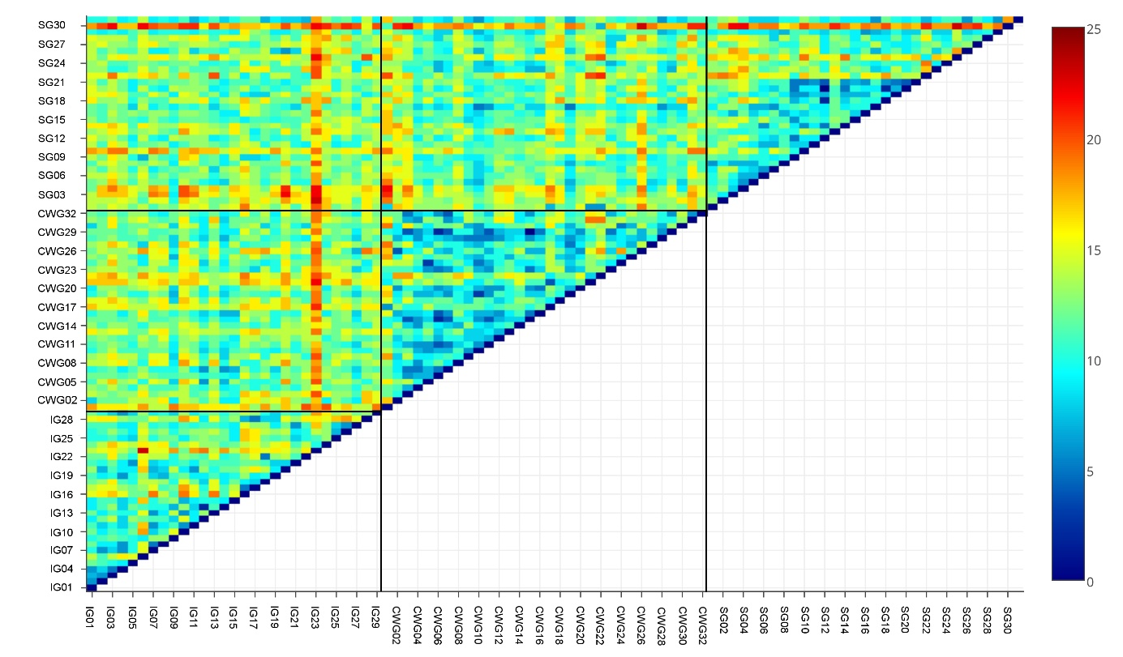
Figure 1. Heat map visualizing the genetic distances between 92 individuals of Istrian (IG), Croatian White (CWG) and Saanen goat (SG). Highly related individuals are indicated with a red color and highly unrelated with blue color. Populations are divided with black line.
The Neighbor-net network obtained with SplitTree4 from Nei distance matrix (Figure 2b) clearly separates IG, while CWG and SG form distinguishable but closer clusters. Basal parts of branches are interwoven suggesting common history although some edges are more straightful as result of admixture.
a)
b)
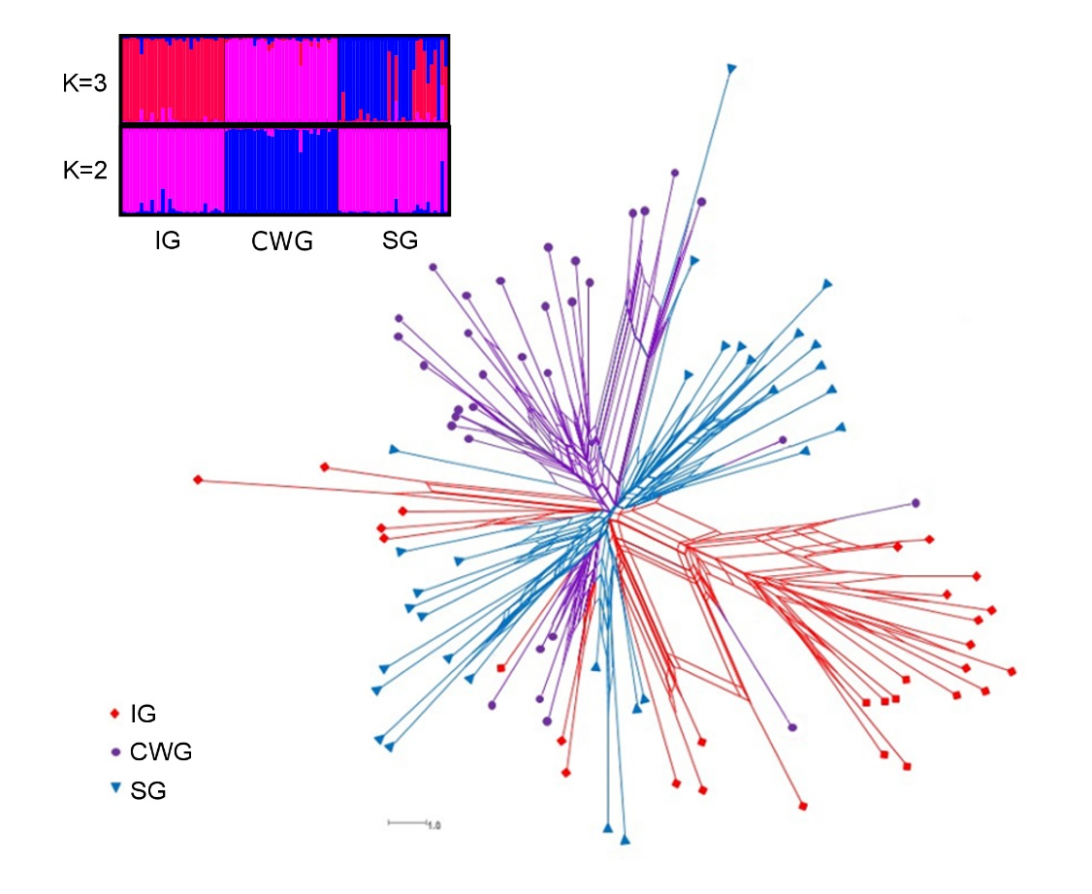
Figure 2. Genetic relationship among the three goat breeds: a) Clustering assignment of the 92 animals represented by a thin vertical line divided into segments. Thin black lines separate breeds (abbreviations ate indicated in Table 2). Panels with K = 2 [IG-SG] – [CWG] and K = 3 [IG]-[SG]-[CWG] inferred clusters are represented; b) Neighbor-Net graph.

Model-based clustering (Pritchard et al., 2000) shows that the most likely number of clusters is three. As shown in Figure 2a, results for K=2 indicate assignment of IG and SG to one cluster with membership coefficient (q) of 0.948 and 0.949, while CWG forms private cluster (q=0.966). The clear subdivision appeared at K=3, setting IG (q of 0.930) and CWG (q=0.944) into their own cluster. Only SG had lover value q=0.706 within its own cluster and 25.4% of individuals are assigned to cluster of IG. The structuring of goat populations into three distinct and non-overlapping groups is further supported from factorial correspondence analysis (FCA, data not shown). It implied the highest variation between CWG and group [IG-SG] placed at opposite side of PC1 which explained 56.19% of the variation. PC2 split IG and SG populations into two separate clusters and explained additional 43.81% of the variation found in the data set. The AMOVA of the three populations showed that 91% of total genetic variation is partitioned within individuals, and 8% among populations (data not shown), which is exactly in accordance with the F_{ST} value. A very similar pattern of variance partitioning has been seen in several other studies of sheep breeds (Serrano et al., 2009; Salles et al., 2011) where 92% of the variation is contained within breeds. However, in this research, there is evidence of admixture between all three goat populations. Results from Structure analyses (Figure 2a) revealed that 31% of SG is assigned to IG cluster with a probability of more than 58.0%, while four of them were assigned with probability ranging from 79.8% to 94.1%. In other two populations, only one individual of CWG was placed into IG cluster with probability of 27.85% and two individuals from IG into cluster of CWG with 17.1% and 15.3% accuracy. Long outstanding branches (Figure 2b), and high admixture level (Figure 1, Figure 2a) reflects that these individuals should be taken very carefully as potential candidates for matting scheme in breeding program. These results are not unexpected because at the beginning of XX century, both breeds, IG and CWG was crossed with Saanen bucks to increase production.
In the present study, Wilcoxon signed-rank test under SMM and TPM accepted the null hypothesis revealing the non-significant P-value and acceptance of mutation-drift equilibrium in all breeds under mentioned models. The qualitative test for mode shift based on allele proportions at low frequency provide L-shaped curve, denoting the absence of a recent (2N_{e}-4N_{e} generations) genetic bottleneck.

Analysis of mtDNA
The 249-bp fragment of the mtDNA D-loop region from twenty-one female animals was sequenced (Table 4). In the population of IG, twenty-one polymorphic sites and teen different haplotypes (Hp) were observed. The share of polymorphic positions in relation to the whole sequence was 8.43%. All nucleotide substitutions were caused by transitions (12 transitions C↔T, nine transitions A↔G). Compared to the Reference Sequence (GU068049), observed haplotypes differ in 3 to 7 nucleotide substitutions (transitions). The most common observed haplotype is Hp 07 (28.57%), while five haplotypes (Hp 01, Hp 03, Hp 06, Hp 08, Hp 10) are observed in only one sample. Haplotypes Hp 05 and Hp 09 are found in two samples, while haplotypes Hp 02 and Hp 04 in three samples.

Table 4. Haplotypes and nucleotide substitutions observed in Istrian goat relative to the Capra hircus reference sequence GenBank GU068049
Haplotype (Hp) | No. observed haplotype | Haplotype frequency (%) | Nucleotide differences from reference sequence
Haplotype (Hp) | No. observed haplotype | Haplotype frequency (%) | 15788  15798  15811  15835  15842  15843  15870  15873  15887  15920  15930  15945  15950  15973  15974  15975  15978  15981  15982  15983  15992
Haplotype (Hp) | No. observed haplotype | Haplotype frequency (%) | CTTAAGTACGTCTGCTTCGGA
Hp.01 | 1 | 4.76 | ..C.......C.C..CCT...
Hp.02 | 3 | 14.29 | .CC..........AT......
Hp.03 | 1 | 4.76 | ...G.A..TA......CT...
Hp.04 | 3 | 14.29 | ..C....G...T...C.T...
Hp.05 | 2 | 9.52 | T.C.........C........
Hp.06 | 1 | 4.76 | T.C...C..A..C..C.T...
Hp.07 | 6 | 28.57 | T.C.G............T...
Hp.08 | 1 | 4.76 | T.C.G....A.........AG
Hp.09 | 2 | 9.52 | .....A.......A....A..
Hp.10 | 1 | 4.76 | T.C.G.......C......A.

Haplotypes observed within the population of IG differ from 2 to 11 nucleotide mutations, compared to the investigated sequence length from 0.08 to 4.42% (Table 5). The highest difference was observed between Hp 03 and Hp 10 (11 nucleotide differences), while the smallest difference was observed between Hp 05 and Hp 10. Genetic distance of haplotypes within the IG were 0.008 – 0.046. The overall mean distance of the observed mtDNA haplotype of Istrian goats was 0.0249 ± 0.0057. Based on the observed number of haplotypes and its diversity it can be concluded that in the IG population significant variability of the maternal component was maintained.

Table 5. Kimura two-parameter distances (above diagonal) and number of nucleotide differences (below the diagonal) among four goat lineages (A, B, C, D) and ten mtDNA haplotypes observed in population of Istrian goat
 | Lin.A | Lin.B | Lin.C | Lin.D | Hp.01 | Hp.02 | Hp.03 | Hp.04 | Hp.05 | Hp.06 | Hp.07 | Hp.08 | Hp.09 | Hp.10
Lin.A | - | 0.069 | 0.093 | 0.051 | 0.025 | 0.016 | 0.025 | 0.021 | 0.012 | 0.029 | 0.016 | 0.025 | 0.012 | 0.021
Lin.B | 16 | - | 0.093 | 0.079 | 0.060 | 0.079 | 0.070 | 0.074 | 0.074 | 0.065 | 0.079 | 0.089 | 0.065 | 0.084
Lin.C | 21 | 21 |  | 0.103 | 0.103 | 0.093 | 0.103 | 0.108 | 0.098 | 0.088 | 0.113 | 0.093 | 0.088 | 0.098
Lin.D | 12 | 18 | 23 | - | 0.060 | 0.060 | 0.060 | 0.074 | 0.065 | 0.074 | 0.069 | 0.060 | 0.056 | 0.065
Hp.01 | 6 | 14 | 23 | 14 | - | 0.033 | 0.033 | 0.021 | 0.021 | 0.021 | 0.025 | 0.042 | 0.038 | 0.029
Hp.02 | 4 | 18 | 21 | 14 | 8 | - | 0.042 | 0.029 | 0.021 | 0.038 | 0.025 | 0.033 | 0.021 | 0.029
Hp.03 | 6 | 16 | 23 | 14 | 8 | 10 | - | 0.038 | 0.038 | 0.038 | 0.033 | 0.042 | 0.029 | 0.046
Hp.04 | 5 | 17 | 24 | 17 | 5 | 7 | 9 | - | 0.025 | 0.025 | 0.021 | 0.038 | 0.033 | 0.033
Hp.05 | 3 | 17 | 22 | 15 | 5 | 5 | 9 | 6 | - | 0.016 | 0.012 | 0.021 | 0.025 | 0.008
Hp.06 | 7 | 15 | 20 | 17 | 5 | 9 | 9 | 6 | 4 | - | 0.021 | 0.029 | 0.042 | 0.025
Hp.07 | 4 | 18 | 25 | 16 | 6 | 6 | 8 | 5 | 3 | 5 | - | 0.016 | 0.029 | 0.012
Hp.08 | 6 | 20 | 21 | 14 | 10 | 8 | 10 | 9 | 5 | 7 | 4 | - | 0.038 | 0.012
Hp.09 | 3 | 15 | 20 | 13 | 9 | 5 | 7 | 8 | 6 | 10 | 7 | 9 | - | 0.033
Hp.10 | 5 | 19 | 22 | 15 | 7 | 7 | 11 | 8 | 2 | 6 | 3 | 3 | 8 | -
Lin.A, GU068049; Lin.D, HQ596553; Lin.C, HQ596552; Lin.B, HQ596551
All haplotypes observed in the population of IG belong to dominant lineage A. The phylogenetic relationship of haplotypes observed in the population of IG (Hp 01 to Hp 10) versus the reference sequences of the most common lineages (A, B, C, D) observed within goat breeds is shown in Figure 3. Earlier studies (Luikart et al., 2001; Naderi et al., 2007; Sultana et al., 2003) have shown that lineage A is dominant in current goat's breeds, while other lineages are much less common and are result of a second domestication and recent expansion.
Figure 3. The neighbour-joining tree of observed haplotype and four goat lineages based on the D-loop region mtDNA.

By comparison of the haplotype sequence from this study with a hundred and forty three of published sequences of the mtDNA D-loop region (15 749 –15 997), which are available in the GenBank database, hundred and twenty four polymorphic sites were observed. Observed haplotypes in the IG population are retained within lineage A (Figure 4) of which two haplotypes (Hp 09, Hp 03) show a certain correlation with haplotypes observed in some Chinese goat breeds (Huanghuai, Matou), but they are represented at low frequency. Most of the observed haplotypes show a separate grouping (Hp 05, Hp 07, Hp 08, Hp 10, Hp 01, Hp 04). Further, IG Hp 02 is associated with haplotype unique to Sannen goat, and the Hp 06 to Girgentan goat breed population that originates from the province of Agrigento in Sicily. Thus, it can be concluded that IG belongs to a group of white goats as Sannen and Girgentana breeds.

Figure 4. The neighbour-joining tree showing the relationship among 153 partial mtDNA sequences from members of the genus Capra including ten haplotypes of Istrian goat (♦).

Results for conservation priorities of three goat breeds from this research are presented in Figure 5. IG population had the greatest contribution to total allelic diversity (2.653) compared to SG (2.224) and CWG (1.949). This is the result of the highest within-subpopulation contribution (2.168) and rather large between-subpopulation contributions (0.485) of IG in comparison to other two breeds. In scenario when one subpopulation is disregarded and contribution to allelic diversity loose or gain is recalculated, removing of IG will produce maximal depletion of diversity.
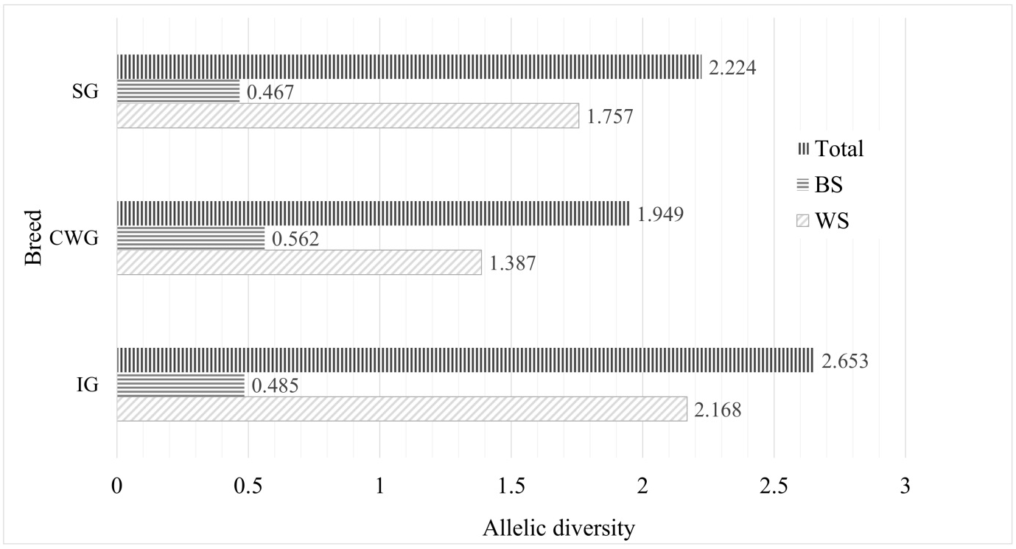
Figure 5. Proportional contribution of Istrian, Croatian White and Saanen goat to total allelic diversity (partitioned as within, between and total population diversity).

Observations from this research provide basis for sustainable genetic diversity management of IG and possibility for development of economical utilization primarily through milk production. Phenotype characteristics and well developed udder with production capacity provides good potential of IG for milk yield (Mioč et al., 2013). It is important to determine quantitative and qualitative parameters of milk by tracking population trends for sustainable production in the future.

Conclusions
Based on paternal and maternal genetic component, it can be concluded that Istrian goat, despite the bans of keeping goats in the past, maintains high level of genetic diversity. Analysis of mtDNA suggests protecting less represented haplotypes and keeping of more representative ones, although not in the same priority sense. These results will be useful in planning strategies for utilization of Istrian goat in milk production in the future, as well as maintaining observed genetic variability.

Genetska karakterizacija istarske koze: polazište dugoročnog očuvanja

Sažetak
Istarska koza jedna je od autohtonih pasmina koja je nastanjivala područje Istarskog poluotoka i bila važna u proizvodnji mlijeka te prehrani, posebice siromašnog stanovništva. Kroz stoljeća je činila prepoznatljivi heraldički simbol Istre, no u svojem stvarnom obličju gotovo je iščezla iz uzgojnog područja. Revitalizacija i reafirmacija istarske koze započela je nakon višedesetljetne zabrane uzgoja na uzgojnoj bazi od nekoliko desetaka preostalih rasplodnih jedinki. Genetska karakterizacija preostale populacije istarske koze nužna je za uvid u stanje unutar populacijske genetske očuvanosti kao i pozicioniranje naspram filogenetski srodnih pasmina koza. Provedena je analiza strukture mikrosatelita i mtDNA rasplodnih jedinki istarske koze te srodnih pasmina koza, hrvatske bijele i sanske koze. U populaciji istarske koze naspram druge dvije pasmine koza utvrđena je veća alelna varijabilnost (nA = 9,7; AR = 7,4) te značajna genetska udaljenost (F_{ST} = 0,068 - 0,086) što ukazuje da istarska koza čini zaseban genetski identitet. Zapaženih deset haplotipova sekvenci D-loop regije mtDNA također potvrđuje značajno genetsko bogatstvo maternalne nasljedne komponente. Uočeni haplotipovi u populaciji istarske koze pripadaju haplogrupi A. Manji broj haplotipova pokazuje srodnost naspram pasmina iz skupine bijelih koza, što indicira na tragove ranijih ograničenih ciljanih oplemenjivanja istarske koze. Analiza genetskog profila ukazuje na visoku razinu očuvanosti genetske varijabilnosti te nudi smjernice dugoročno održivog konzervacijskog programa. Očuvani genetski i izgledni proizvodni (mliječni) potencijal istarske koze čini značajnu osnovu njene gospodarske reafirmacije.

Ključne riječi: istarska koza, genetska različitost, mikrosateliti, mtDNA, očuvanje

References.
- Belkhir, K., Borsa, P., Chikhi, L., Raufaste, N., Bonhomme, F. (2004): GENETIX 4.05, Logiciel sous Windows TM pour la Génétique des Populations. Laboratoire Génome, Populations, Interactions, CNRS UMR 5000, Université de Montpellier II, Montpellier. (http://kimura.univ-montp2.fr/genetix/)
- Beltram, V., Klanjšček, V. (1947): Velik broj koza – velike štete u šumarstvu. Šumarski list, 33-36.
- Botstein, D., White, R.L., Skolnick, M., Davis, R.W. (1980): Construction of a genetic linkage map in man using restriction fragment length polymorphisms. American Journal of Human Genetics 32, 314-331.
- Bulut, Z., Kurar, E., Ozsensoy, Y., Altunok, V., Nizamlioglu, M. (2016): Genetic Diversity of Eight Domestic Goat Populations Raised in Turkey. BioMed Research International. Article ID 2830394 (http://dx.doi.org/10.1155/2016/2830394).
- Colli, L., Lancioni, H., Cardinali, I., Olivieri, A., Rosario Capodiferro, M., Pellecchia, M., Rzepus, M., Zamani, W., Naderi, S., Gandini, F., Vahidi, S.M.F., Agha, S., Randi, E., Battaglia, V., Sardina, M.T., Portolano, B., Rezaei, H.R., Lymberakis, P., Boyer, F., Coissac, E., Pompanon, F., Taberlet, P., Marsan, P.A., Cornuet, A.A. (2015): Whole mitochondrial genomes unveil the impact of domestication on goat matrilineal variability. BMC Genomics 16, 1115. (https://doi.org/10.1186/s12864-015-2342-2).
- Cornuet, J.M., Luikart, G. (1996): Description and power analysis of two tests for detecting recent population bottlenecks from allele frequency data. Genetics 144(4), 2001-2014.
- CAA (2016): Annual Report. Croatian Agricultural Agency, Križevci, Croatia.
- DAD-IS (2017): Domestic Animal Diversity Information System. (http://www.fao.org/dad-is/en/)
- Doro, M.G., Piras, D., Leoni, G.G., Casu, G., Vaccargiu, S., Parracciani, D., Naitana, S., Pirastu, M., Novelletto, A. (2014): Phylogeny and Patterns of Diversity of Goat mtDNA Haplogroup A Revealed by Resequencing Complete Mitogenomes. PLOS^{ONE} 9(4). (https://doi.org/10.1371/journal.pone.0095969).
- Dovč, P., Kavar, T., Sölkner, H., Achmann, R. (2006): Development of the Lipizzan Horse Breed. Reproduction in Domestic Animals 41, 280-285.
- Excoffier, L., Lischer, H.E. (2010): Arlequin suite ver 3.5: A new series of programs to perform population genetics analyses under Linux and Windows. Molecular Ecology Resources 10, 564-567.
- FAO (2015): The Second Report on the state of the World’s Animal Genetic Resources for Food and Agriculture. Rome. Available on: http://www.fao.org/3/a-i4787e.pdf
- FAOSTAT (2015): Food and agriculture data. (http://www.fao.org/faostat/en/#home)
- Goudet, J. (2002): FSTAT, a program to estimate and test gene diversities and fixation indices (version 2.9.3.2). Available on: http://www2.unil.ch/popgen/softwares/fstat.htm
- Huson, D.H., Bryant, D. (2006): Application of phylogenetic networks in evolutionary studies. Molecular Biology and Evolution 23, 254-267.
- Joshi, M.B., Rout, P.K., Mandal, A.K., Tyler-Smith, C., Singh, L., Thangara, J.K. (2004): Phylogeography and origin of Indian domestic goats. Molecular Phylogenetics and Evolution 21: 454-462.
- Kimura, M. (1980): A simple method for estimating evolutionary rate of base substitution through comparative studies of nucleotide sequences. Journal of Molecular Evolution 16, 111-120.
- Kumar, S., Stecher, G., Tamura, K. (2016): Mega7: Molecular Evolutionary Genetics Analysis version 7.0 for bigger datasets. Molecular Biology and Evolution 33, 1870-1874.
- Liu, R.Y., Lei, C.Z., Liu, S.H., Yang, G.S. (2007): Genetic Diversity and Origin of Chinese Domestic Goats Revealed by Complete mtDNA D-loop Sequence Variation. Asian-Australasian Journal of Animal Sciences 20 (2), 178 – 183.
- Liu, J.B., Wang, F., Lang, X., Zha, X., Sun, X.P, Yue, Y.J., Feng, R.L., Yang, H.B., Guo, J. (2013). Analysis of Geographic and Pairwise Distances among Chinese Cashmere Goat Populations. Asian-Australasian Journal of Animal Sciences 26 (3), 323–333.
- Luikart, G.L., Allendorf, F.W., Cornuet, J.M., Sherwin, W.B. (1998): Distortion of allele frequency distributions provides a test for recent population bottlenecks. Journal of Heredity 89, 238-247.
- Luikart, G., Giellly, L., Excoffier, L., Vigne, J.D., Bouuvet, J., Taberlet, P. (2001): Multiple maternal origins and weak phylogeographic structure in domestic goats. Proc. National Academy of Sciences USA 98: 5927-5932.
- Medugorac, I., Medugorac, A., Russ, I., Veit-Kensch, C.E., Taberlet, P., Luntz, B., Mix, H.M., Forster, M. (2009): Genetic diversity of European cattle breeds highlights the conservation value of traditional unselected breeds with high effective population size. Molecular Ecology 18, 394–410.
- Meng-Hua, L., Shu-Hong, Z., Ci, B., Hai-Sheng, W., Hong, W., Bang, L., Mei, Y., Bin, F., Shi-Lin, C., Meng-Jin, Z., Shi-Jun, L., Tong-An, X., Kui, L. (2002). Genetic relationships among twelve Chinese indigenous goat populations based on microsatellite analysis. Genetics Selection Evolution 34, 729–744.
- Mioč, B., Pavić, V., Barać, Z., Prpić, Z., Vnučec, I. (2007): Milk yield of some goats breeds in Croatia. Mljekarstvo 57 (1), 67-77.
- Mioč, B., Ivanković, A., Širić, I., Držaić, V. (2013): Odlike vanjštine istarske koze. Zbornik radova 48. hrvatskog i 8. međunarodnog simpozija agronoma. 17-22.02.2013., Dubrovnik, 765-769.
- Naderi, S., Rezaei, H.R., Taberlet, P., Zundel, S., Rafat, S.A., Naghash, H.R., El-Barody, M.A.A., Ertugrul, O., Pompanon, F., Harpending, H. (2007): Largescale mitochondrial DNA analysis of the domestic goat reveals six haplogroups with high diversity. PLoS ^{ONE} 2(10), e1012. (https://doi:10.1371/journal.pone.0001012)
- National Gazette (80/2013): Dopuna popisa izvornih i zaštićenih pasmina i sojeva domaćih životinja te njihov potrebit broj. Available on: https://narodne-novine.nn.hr/clanci/sluzbeni/2013_06_80_1688.html
- Nei, M., Tajima, F., Tateno, Y. (1983): Accuracy of estimated phylogenetic trees from molecular data. Journal of Molecular Evolution 19, 153–170.
- Pereira, F., Pereira, L., Van Asch, B., Bradley, D.G., Amorim, A. (2005): The mtDNA catalogue of all Portuguese autochthonous goat (Capra hircus) breeds: high diversity of female lineages at the western fringe of European distribution. Molecular Ecology 14, 2313–2318.
- Pérez-Figueroa, A., Saura, M., Fernández, J., Toro, M.A., Caballero, A. (2009): Metapop - a software for the management and analysis of subdivided populations in conservation programs. Conservation Genetics 10, 1097–1099.
- Piras, D., Doro, M.G., Casu, G., Melis, M.P., Vaccargiu, S., Piras, I., Parracciani, D., Stradoni, R., Frongia, B., Lai, G., Sale, S., Cattari, W., Piras, R., Querci, O., Demuro, P., Cui, S., Atzori, F., Mancosu, M., Marchiori, F., Cammelli, R., Spiga, A., Loddo, P.P., Pili, G., Boi, R., Argiolas, G., Mereu, P., Leoni, G.G., Naitana, S., Pirastu, M., Novelletto, A. (2012): Haplotype affinities resolve a major component of goat (Capra hircus) mtDNA D-loop diversity and reveal specific features of the Sardinian stock. PLoS ^{ONE} 7, e30785. (https://doi.org/10.1371/journal.pone.0030785)
- Piry, S., Luikart, G., Cornuet J.M. (1999): Bottleneck: a program for detecting recent effective population size reductions from allele frequency data. Journal of Heredity 90, 502-503.
- Pritchard, J.K., Stephens, M., Donnelly, P. (2000): Inference of population structure using multilocus genotype data. Genetics 155, 945–959.
- Ramljak, J., Mioč, B., Ćurković, M., Pavić, V., Ivanković, A., Međugorac, I. (2011): Genetic diversity measures of Croatian Spotted goat. Acta veterinaria 61, 373-382.
- Rosenberg, N.A. (2004): Distruct: A program for the graphical display of population structure. Molecular Ecology Notes 4, 137–138.
- Rousset, F. (2008): Genepop’007: A complete re-implementation of the genepop software for Windows and Linux. Molecular Ecology Resources 8, 103–106.
- Saitou, N., Nei, M. (1987): The neighbor-joining method: a new method for reconstructing phylogenetic trees. Molecular Biology and Evolution 4, 406-425.
- Salles, P.A., Santos, S.C., Rondina, D., Weller, M. (2011): Genetic variability of six indigenous goat breeds using major histocompatibility complex-associated microsatellite markers. Journal of Veterinary Science 12(2), 127–132.
- Sardina, M.T., Ballester, M., Marmi, J., Finocchiaro, R., van Kaam, J.B., Portolano, B., Folch, J.M. (2006): Phylogenetic analysis of Sicilian goats reveals a new mtDNA lineage. Animal Genetics 37(4), 376–378.
- Seilsuth, S., Seo, J.H., Kong, H.S., Jeon, G.J. (2016): Microsatellite Analysis of the Genetic Diversity and Population Structure in Dairy Goats in Thailand. Asian-Australasian Journal of Animal Sciences 29 (3), 327-332.
- Serrano, M., Calvo, J.H., Martínez, M., Marcos-Carcavilla, A., Cuevas, J., González, Jurado, J.J., Díez de Tejada, P. (2009): Microsatellite based genetic diversity and population structure of the endangered Spanish Guadarrama goat breed. BMC Genomics 10, 61.
- Sultana, S., Mannen, H., Tsuji, S. (2003): Mitochondrial DNA diversity of Pakistani goats. Animal Genetics 34 (6), 417-421.
- Takezaki, N., Nei, M. (1996): Genetic distances and reconstruction of phylogenetic trees from microsatellite DNA. Genetics 144, 389-399.
- Thompson, J.D., Higgins, D.G., Gibson, T.J. (1994): CLUSTAL W: improving the sensitivity of progressive multiple sequence alignment through sequence weighting, position-specific gap penalties and weight matrix choice. Nucleic Acids Research 22(22): 4673-4680.
- White, P.S., Densmore, L.D. (1992): Mitochondrial DNA isolation: Molecular genetic analysis of populations. A practical approach. Oxford, Oxford University Press, UK.
- Zeder, M.A., Hesse, B. (2000): The initial domestication of goats (capra hircus) in the Zagros Mountains 10,000 years ago. Science 287, 2254-2257.
- Zeder, M.A., Emshwiller, E., Smith, B.D., Bradley, D.G. (2006): Documenting domestication: the intersection of genetics and archaeology. Trends in Genetics 22 (3), 139-155.

